Applications of Machine learning

Machine learning is a buzzword for today's technology, and it is growing very rapidly day by day. We are using machine learning in our daily life even without knowing it such as Google Maps, Google assistant, Alexa, etc. Below are some most trending real-world applications of Machine Learning:

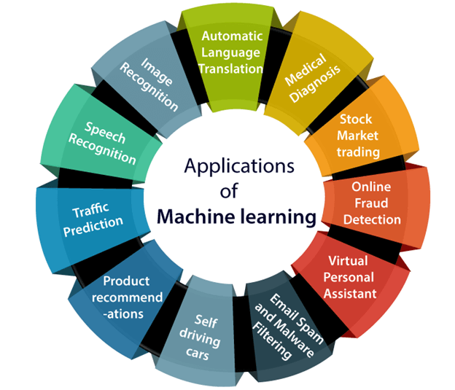

1. Image Recognition:

Image recognition is one of the most common applications of machine learning. It is used to identify objects, persons, places, digital images, etc. The popular use case of image recognition and face detection is, **Automatic friend tagging suggestion**:

Facebook provides us a feature of auto friend tagging suggestion. Whenever we upload a photo with our Facebook friends, then we automatically get a tagging suggestion with name, and the technology behind this is machine learning's **face detection** and **recognition algorithm**.

It is based on the Facebook project named "**Deep Face**," which is responsible for face recognition and person identification in the picture.

2. Speech Recognition

While using Google, we get an option of "**Search by voice**," it comes under speech recognition, and it's a popular application of machine learning.

Speech recognition is a process of converting voice instructions into text, and it is also known as "**Speech to text**", or "**Computer speech recognition**." At present, machine learning algorithms are widely used by various applications of speech recognition. **Google assistant**, **Siri**, **Cortana**, and **Alexa** are using speech recognition technology to follow the voice instructions.

3. Traffic prediction:

If we want to visit a new place, we take help of Google Maps, which shows us the correct path with the shortest route and predicts the traffic conditions.

It predicts the traffic conditions such as whether traffic is cleared, slow-moving, or heavily congested with the help of two ways:

* **Real Time location** of the vehicle form Google Map app and sensors
* **Average time has taken** on past days at the same time.

Everyone who is using Google Map is helping this app to make it better. It takes information from the user and sends back to its database to improve the performance.

4. Product recommendations:

Machine learning is widely used by various e-commerce and entertainment companies such as **Amazon**, **Netflix**, etc., for product recommendation to the user. Whenever we search for some product on Amazon, then we started getting an advertisement for the same product while internet surfing on the same browser and this is because of machine learning.

Google understands the user interest using various machine learning algorithms and suggests the product as per customer interest.

As similar, when we use Netflix, we find some recommendations for entertainment series, movies, etc., and this is also done with the help of machine learning.

5. Self-driving cars:

One of the most exciting applications of machine learning is self-driving cars. Machine learning plays a significant role in self-driving cars. Tesla, the most popular car manufacturing company is working on self-driving car. It is using unsupervised learning method to train the car models to detect people and objects while driving.

6. Email Spam and Malware Filtering:

Whenever we receive a new email, it is filtered automatically as important, normal, and spam. We always receive an important mail in our inbox with the important symbol and spam emails in our spam box, and the technology behind this is Machine learning. Below are some spam filters used by Gmail:

* Content Filter
* Header filter
* General blacklists filter
* Rules-based filters
* Permission filters

Some machine learning algorithms such as **Multi-Layer Perceptron**, **Decision tree**, and **Naïve Bayes classifier** are used for email spam filtering and malware detection.

7. Virtual Personal Assistant:

We have various virtual personal assistants such as **Google assistant**, **Alexa**, **Cortana**, **Siri**. As the name suggests, they help us in finding the information using our voice instruction. These assistants can help us in various ways just by our voice instructions such as Play music, call someone, Open an email, Scheduling an appointment, etc.

These virtual assistants use machine learning algorithms as an important part.

These assistant record our voice instructions, send it over the server on a cloud, and decode it using ML algorithms and act accordingly.

8. Online Fraud Detection:

Machine learning is making our online transaction safe and secure by detecting fraud transaction. Whenever we perform some online transaction, there may be various ways that a fraudulent transaction can take place such as **fake accounts**, **fake ids**, and **steal money** in the middle of a transaction. So to detect this, **Feed Forward Neural network** helps us by checking whether it is a genuine transaction or a fraud transaction.

For each genuine transaction, the output is converted into some hash values, and these values become the input for the next round. For each genuine transaction, there is a specific pattern which gets change for the fraud transaction hence, it detects it and makes our online transactions more secure.

9. Stock Market trading:

Machine learning is widely used in stock market trading. In the stock market, there is always a risk of up and downs in shares, so for this machine learning's **long short term memory neural network** is used for the prediction of stock market trends.

10. Medical Diagnosis:

In medical science, machine learning is used for diseases diagnoses. With this, medical technology is growing very fast and able to build 3D models that can predict the exact position of lesions in the brain.

It helps in finding brain tumors and other brain-related diseases easily.

11. Automatic Language Translation:

Nowadays, if we visit a new place and we are not aware of the language then it is not a problem at all, as for this also machine learning helps us by converting the text into our known languages. Google's GNMT (Google Neural Machine Translation) provide this feature, which is a Neural Machine Learning that translates the text into our familiar language, and it called as automatic translation.

The technology behind the automatic translation is a sequence to sequence learning algorithm, which is used with image recognition and translates the text from one language to another language.